# Intro Exercise

Implement a PDF converter (e.g. a web application) that lets customers upload a text document that the application converts into a PDF (or some other format) and sends an email back to the customer (or simulates this).

* Every second, the application receives many PDF converter requests.
* Each request takes a second to process so you need some sort of queue to handle the requests.

## Use case

1. 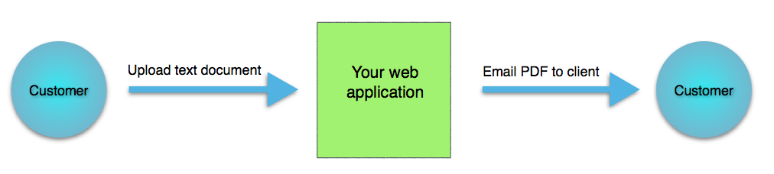Customer uploads a text document
2. Your app converts the document into a PDF
3. Your app sends the PDF back to the customer in email

## Database as queue

Each task must be put into database table, e.g.

INSERT INTO pdf_job (name, status, email) VALUES ("Bible", "NEW", "mymail@mail.com");

You must write:

* code to insert the new requests into the database
* 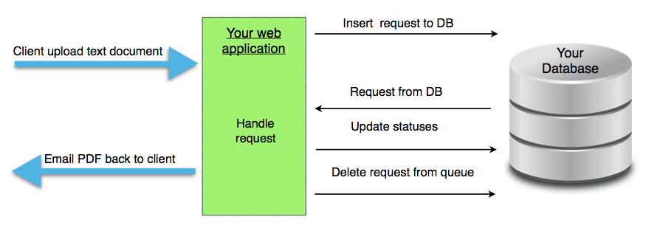code that takes an input from the database, perhaps change a status column, with values such as "NEW" and "PROCESSING"
* code that handles the request
* code that again updates the database status field to "FINISHED" or removes the request from the table.

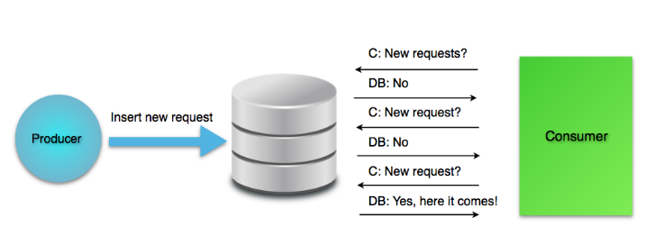

## Considerations

When you implement your solution, have in mind that your application has to ask the server constantly for the latest requests. Requests that have already been consumed already be filtered out.